Zoe Boyle

Lab 9

**Part 1**

Output:



**Part 2**

1. Output:

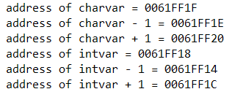

1. Integers are 4 bytes or 32 bits so they can be processed easily by 32-bit computers

**Part 3**

1. Output:

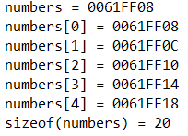

1. The address of the array is the same as the address of the first index
2. printf("sizeof(numbers) = %lu\n", sizeof(numbers));